**IFESINACHI SAMUEL CHUKWU**

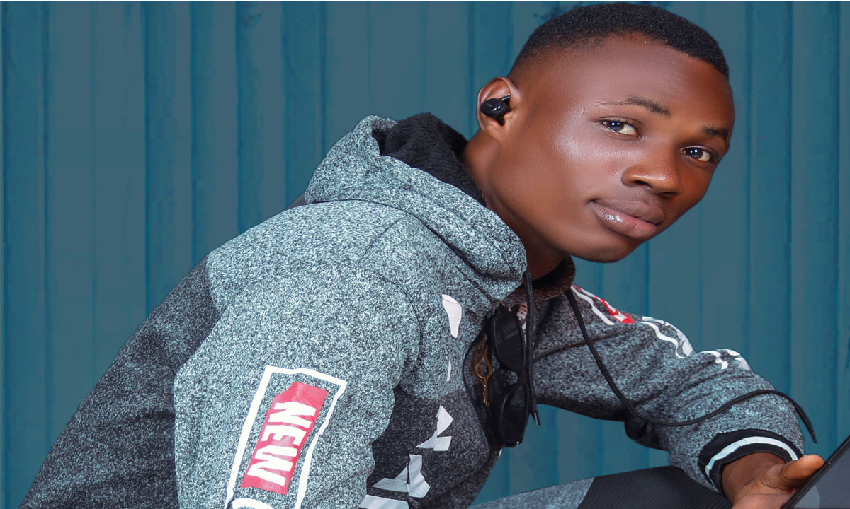

ADDRESS No. 5 ichida Street, Iyiowa, Ogbaru Local Govt

Anambra State.

MOBILE +2348169406746

EMAIL chukwuifesinachi717@gmail.com

**OBJECTIVE**

Highly skilled and detail-oriented WordPress website developer with 2 years of experience in creating visually stunning and user-friendly websites.

Seeking a challenging position to leverage my expertise in WordPress development and design to deliver exceptional web experiences for clients.

.

**PERSONAL DATA**

DATE OF BIRTH 22nd December 2003

SEX Male

MARITAL STATUS Single

RELIGION Christianity

NATIONALITY Nigerian

STATE OF ORIGIN Ebonyi State

L. G. A Ishielu

**STRENGTH AND SKILL**

*Proficient in WordPress development, including theme customization, plugin *integration, and website optimization.

*Strong knowledge of HTML, CSS, JavaScript, and PHP.

*Experience with responsive web design and cross-browser compatibility.

*Familiarity with front-end frameworks and libraries, such as Bootstrap and jQuery.

*Ability to create custom themes and templates based on client requirements.

*Knowledge of SEO best practices and ability to implement SEO strategies in WordPress websites.

*Excellent problem-solving and debugging skills.

*Strong attention to detail and ability to meet project deadlines.

*Developed and maintained WordPress websites for clients, ensuring high-quality standards and exceptional user experiences.

*Collaborated with clients and design teams to translate design concepts into functional WordPress websites.

*Customized themes and templates to match client branding and specifications.

Integrated and configured plugins to enhance website functionality and meet client requirements.

*Conducted thorough testing and debugging to ensure websites were fully functional and optimized.

*Provided ongoing support and maintenance for WordPress websites, including updates and troubleshooting.

*Designed and developed responsive WordPress websites for various clients across different industries.

*Utilized HTML, CSS, JavaScript, and PHP to create custom features and functionality.

*Implemented SEO strategies, including optimizing website structure, meta tags, and content for improved search engine rankings.

*Collaborated with graphic designers to ensure seamless integration of visual elements into WordPress websites.

*Conducted website performance audits and implemented optimization techniques to enhance loading speed and user experience.

*Assisted in website migration and data transfer to WordPress platform.

**EDUCATIONAL QUALIFICATIONS/CERTIFICATES**

2023 Fullstack web developer certificate

Digital Dream Academy , Anambra State Nigeria.

2023 Wordpress website developer certificate

Digital Dream Academy , Anambra State Nigeria.

2022 Divine Destiny International School anambra state Nigeria. (High school)National Examination Council –(NECO)

**WORK EXPERIENCE**

2021 Vic-R Computer Centre, Iyiowa, Ogbaru, Anambra State

POSITION full stack **web developer**

2022 John Kalu ESQ, John Kalu and Co, 125 Market Road Aba, Abia State.

POSITION **wordpress website developer**

**HOBBIESS**

Volley ball, coding, and exercise

-